**Filing of Softex Manual (New)**

Click on Export from left menu following screen will appear:

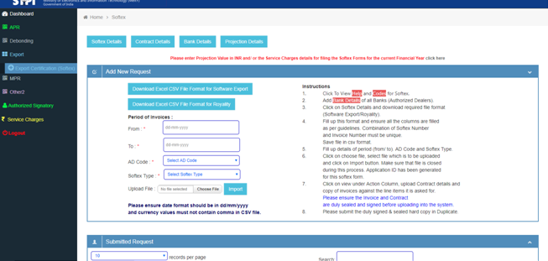

Download CSV (Excel) file format as per the requirement and make sure there is proper number format without comma and no  Scientific notation format, something like 2.5E+07 value is there. If the number is more than 12 digits anywhere ie in Invoice Number put ‘ or any other special character to recognize as character and this will disable the excel to convert the field in Scientific notation. Following are the columns of the file, please make sure of this in your CSV file.

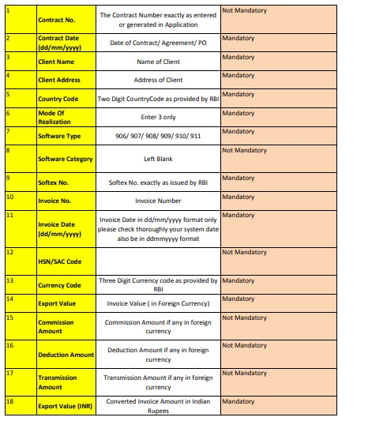

After uploading .CSV (Excel File) a new request been generated with only **View** Option as per the following screen:

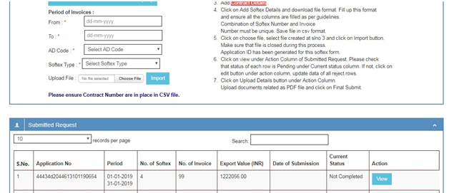

By Clicking on View Button the following screen will appear. It is mandatory to upload invoices and contracts wherever the button is appearing under upload invoice and upload contract column. Details can be updated by clicking button under Action Menu. If you have already uploaded contract / Agreement, there is no need to upload contract again just click on action button and select/ enter the contract number accordingly.

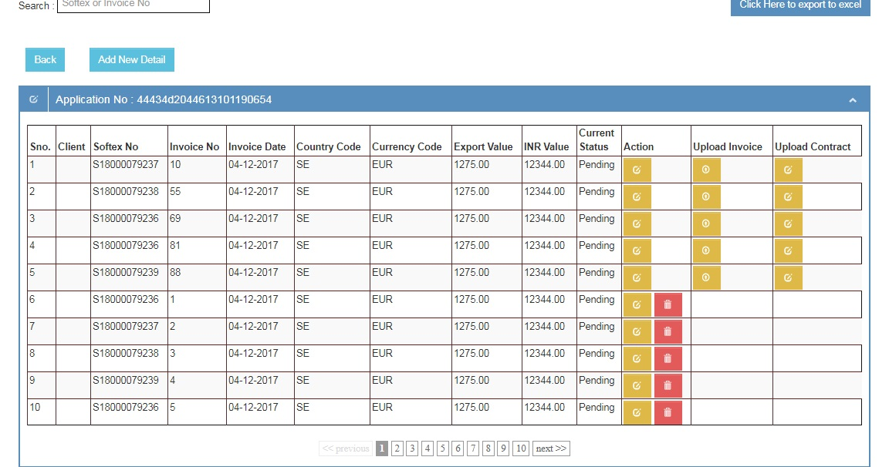

By clicking the Button in Action menu following screen appears to update the particular line item, if you have already uploaded contract into the system please enter exact contract number and update the row, the details will be auto populated:

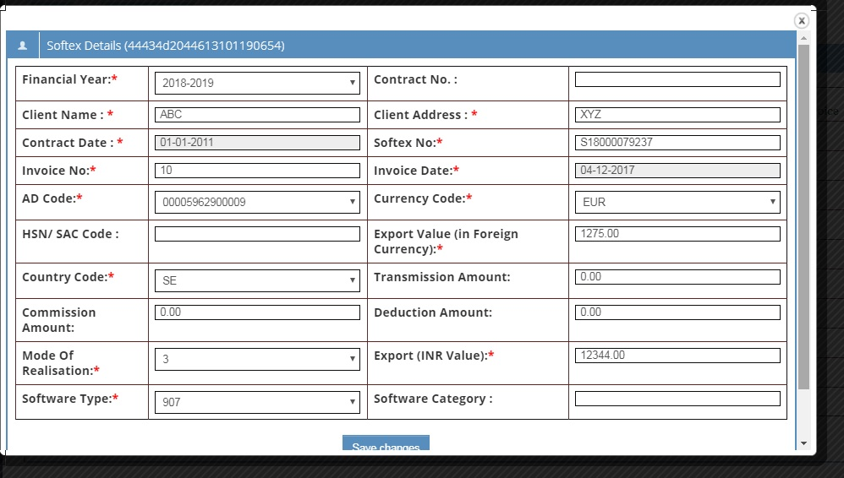

Refer Below screenshot where the client detail is fetched from the system and displayed when the contract/ agreement number is available.

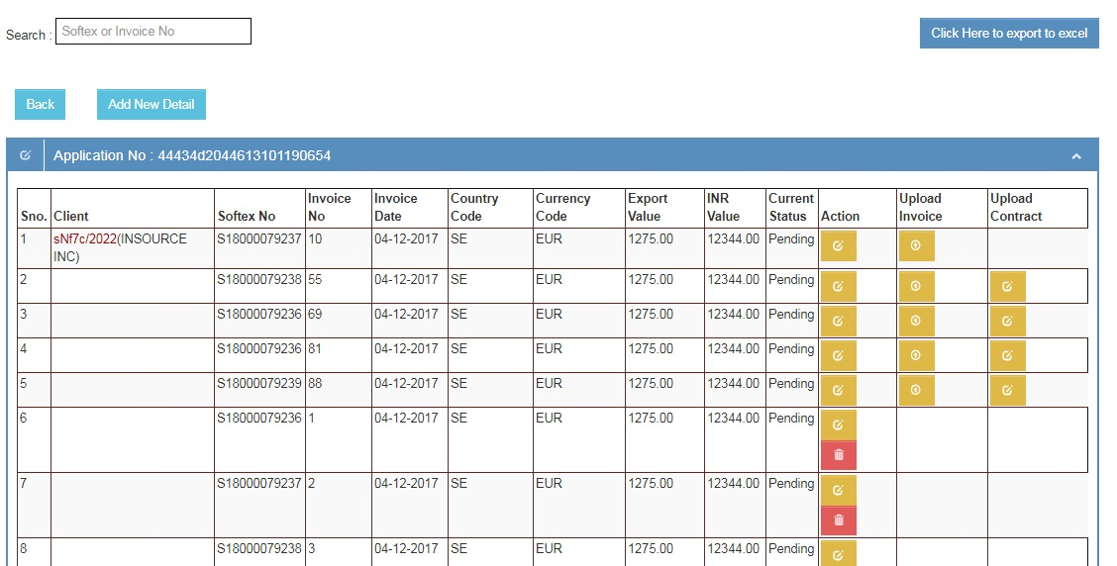

Upload required invoices only

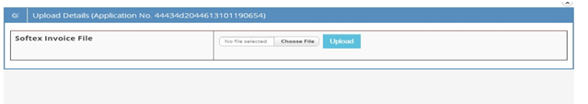

After completion of all the (selected) uploading of Invoices and Contract the Final Submit button will appear in Softex Details.

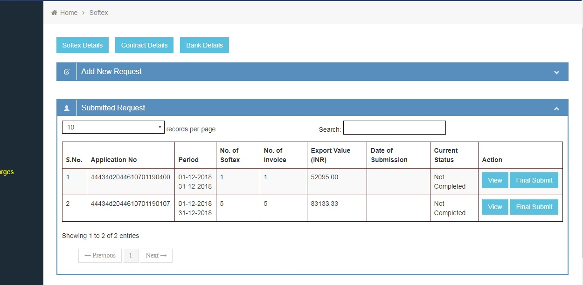

By clicking on Final Submit following screen will appear where the RBI Letter pertaining Softex Numbers , Datacom (Internet) Bill/ Invoice for the period is to be uploaded. Also select location of the Unit from which the Export has been done.

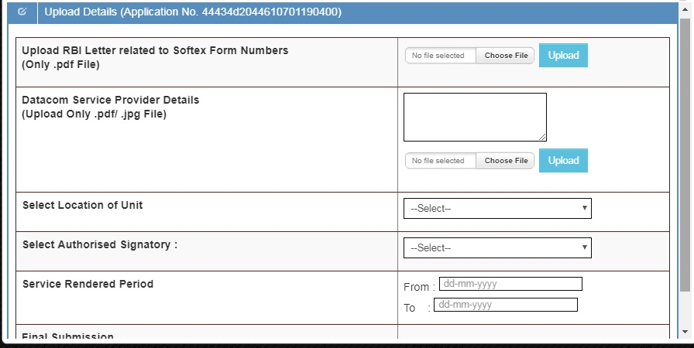

Please note the Service Rendered Period can be different from the period of Invoices for example service rendered or actual export made in the month of October for which the Invoices raised in the month of November, please enter service render period as October and Period of Invoices as November.

After this click on Final Submit to send this Application to STPI make sure of all the details enters/ submitted before clicking on Final Submit

For Non-STP Unit, provision has been made to update year-wise projections.

Upload Digitally Signed Softex PDF Document

After final submission, the following screen will appear. By clicking on Application Number a PDF file of Softex form will get generated which needs to be download.

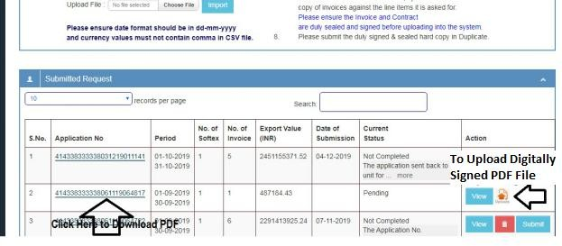

In the downloaded pdf of Softex form, at the last page (Section C) of the softex, a box will appear where unit need to click and add their **digital signature** refer screenshot below (make sure to not to lock the file while signing the PDF)

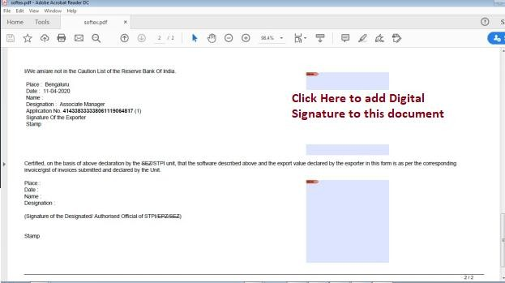

By clicking on upload icon, the following screen will appear where unit needs to upload their **digitally signed pdf** document in **unlock mode**.

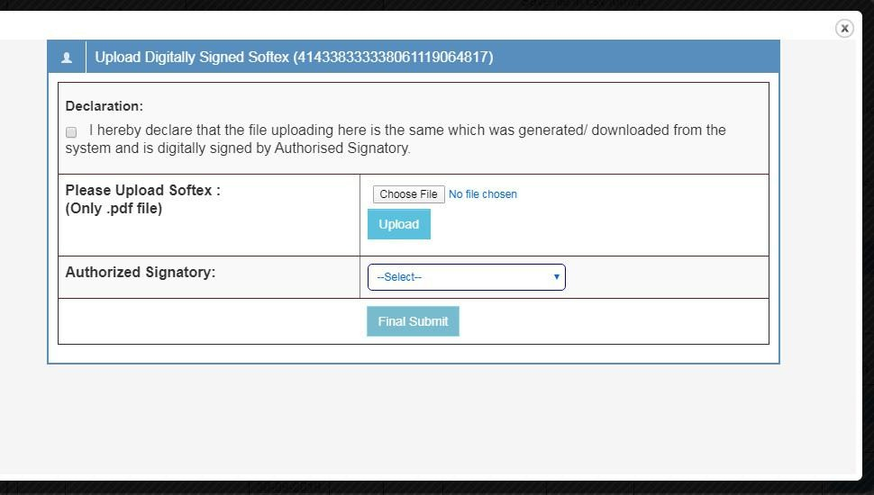

By clicking on Final Submit the date of submission of Softex will get updated.

The duly **Digitally Signed** document (after approval of STPI) may be downloaded as per screenshot 1.

***Please use latest version of Chrome to download the PDF file and to sign the document latest Adobe Acrobat Reader DC also ensure to uncheck or disable the locking mode of the document during the process of signing, enabling us to counter sign the document.***

================